PROJECT REPORT
(Project Term January- May 2024)

EVENTIFY
Shoe website

Submitted by

Name: Omkar Anand Registration Number:12212007 Section: K22MP

Course Code: INT-219
Course Title: Front End Web Developer

Submitted To

Mr. Akhil Sohal Sir

School of Computer Science and Engineering



DECLARATION
We, the undersigned, hereby declare that the project work titled "ShoeHub" is an authentic record of our own efforts undertaken as a requirement for the completion of our Capstone Project, leading to the award of a Bachelor of Technology degree in Computer Science & Engineering from Lovely Professional University, Phagwara. This project was carried out under the guidance of Mr. Akhil Sohal, during the period from January to May 2024.
Name of Student: Omkar Anand
Registration Number: 12212007
Roll Number: 10

Signature of Student
Date:

CERTIFICATE
This is to certify that the declaration statement made by the student is correct to the best of my knowledge and belief. He has completed this Project under my guidance and supervision. The present work is the result of his original investigation, effort, and study. No part of the work has ever been submitted for any other degree at any University. The Project is fit for the submission and partial fulfillment of the conditions for the award of B.Tech degree in Computer Science & Engineering from Lovely Professional University, Phagwara.

Signature and Name of the Staff

Designation

School of Computer Science and Engineering,
Lovely Professional University,
Phagwara, Punjab.
Date :
TABLE OF CONTENTS
Cover page…………………………………………………………………………...(i)
Declaration…...……………………………………………………………………...(ii)
Certificate…….…….………………………………………………………………(iii)
Table of Contents……………………...……………………………………………(iv)

1. INTRODUCTION 1

1.1. PROBLEM STATEMENT 1

2. SOLUTION

Global reach and Accessibility
- 27/7 Availability.
3. TECHNOLOGIES USED 3

4. DESCRIPTION OF PAGES 5

5. ADDITIONAL CONSIDERATIONS 14

6. CONCLUSION 15

- INTRODUCTION

1.1. PROBLEM STATEMENT
In the ever-expanding realm of e-commerce, there is a noticeable gap in the online retail sector, particularly in the footwear industry. Despite the abundance of online shopping platforms, there is a lack of a dedicated and user-friendly website exclusively catering to the needs of shoe enthusiasts.
To fill this void, our project, "ShoeHub," aims to develop a comprehensive online marketplace focused solely on footwear. Our goal is to create a platform that offers a diverse selection of shoe brands, styles, and sizes, all presented through an intuitive digital interface.

GitHub Repository Link =>

SOLUTION

1. Global Reach and Accessibility:
By having a website, you transcend geographical limitations, making your shoe collection accessible to customers worldwide. Whether someone is browsing from the bustling streets of New York City or the tranquil villages of rural Japan, your shoes can reach them with just a few clicks.

2.24/7 Availability:
Unlike brick-and-mortar stores with set opening hours, your website is always open for business. This round-the-clock accessibility ensures that potential customers can explore your shoe offerings at any time that suits them, whether it's during their lunch break or in the quiet hours of the night.

3. TECHNOLOGIES USED

3.1. HTML:
My shoe website leverages the power of HTML to create a seamless and dynamic online experience for visitors. By utilizing HTML, I've crafted an intuitive and visually appealing platform to showcase our extensive collection of shoes.
3.2. CSS:
Adding CSS into my website design, I've elevated the visual and user experience to new heights. With CSS, I've crafted stylish layouts and customized styles, ensuring a captivating presentation of our shoe collection.
3.3.JavaScript:
By integrating JavaScript into my website, I've added interactive features that engage and delight visitors. With JavaScript, I've enhanced functionality, such as dynamic product filtering and smooth animations, enriching the browsing experience on our shoe platform

4. DESCRIPTION OF PAGES

4.1. HomePage for website:
Our homepage showcases a curated selection of 5 top-brand shoes, each offering a choice of 2 color options and 3 size selections. This intuitive interface empowers visitors to explore and select their preferred shoe effortlessly. With a focus on user experience, our design ensures seamless navigation and quick access to desired styles. By integrating color and size options directly on the homepage, we streamline the shopping process, providing a convenient and personalized experience. Whether customers seek versatility or specificity in their footwear, our website caters to their preferences with ease.
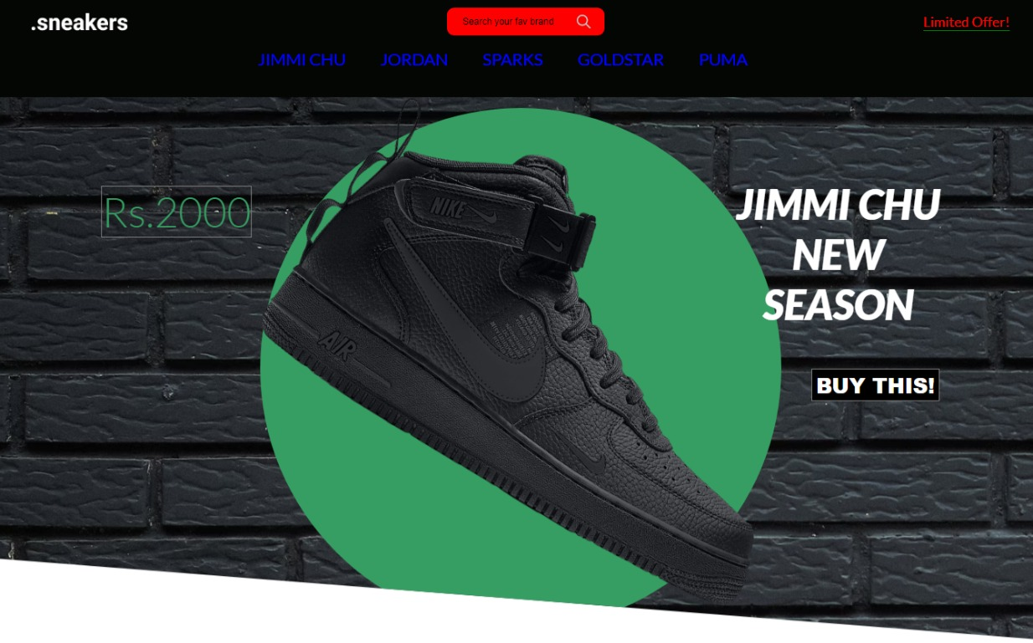

4.2. Enhancing Customer Experience:

Free Shipping: We prioritize customer satisfaction by offering complimentary shipping on all orders. This added value ensures a seamless and cost-effective shopping experience, eliminating barriers to purchase and delighting customers with no extra charges.
- 30-Day Return Policy: Our commitment to quality extends beyond the transaction. Customers enjoy peace of mind with our generous 30-day return policy, empowering them to make confident purchases and facilitating hassle-free returns or exchanges if needed.
- Gift Cards: For those seeking the perfect gift or simply wanting to spread joy, our gift cards provide a flexible and thoughtful solution. Customers can easily purchase and redeem gift cards, allowing recipients to explore our vast shoe collection and find their perfect fit.
- Feedback Option: We value customer input and strive for continuous improvement. Our feedback option encourages customers to share their thoughts, suggestions, and experiences, fostering a dialogue that helps us better understand and meet their needs.

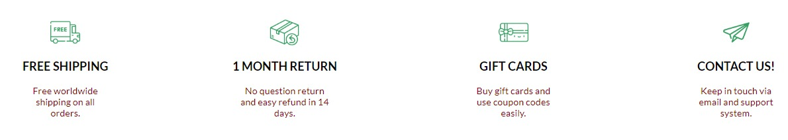

4.3. Shoe Selection Experience :
After selecting their desired shoes from our curated collection, customers are seamlessly guided to a dedicated page for their chosen footwear. Here, detailed descriptions and visuals showcase each shoe's unique features, allowing customers to make informed decisions based on style, material, and craftsmanship.

Our intuitive interface presents customizable options for size and color, empowering customers to tailor their purchase to their preferences effortlessly. With a simple click, customers can select their desired size and color combination, visualizing their chosen shoe in real-time.

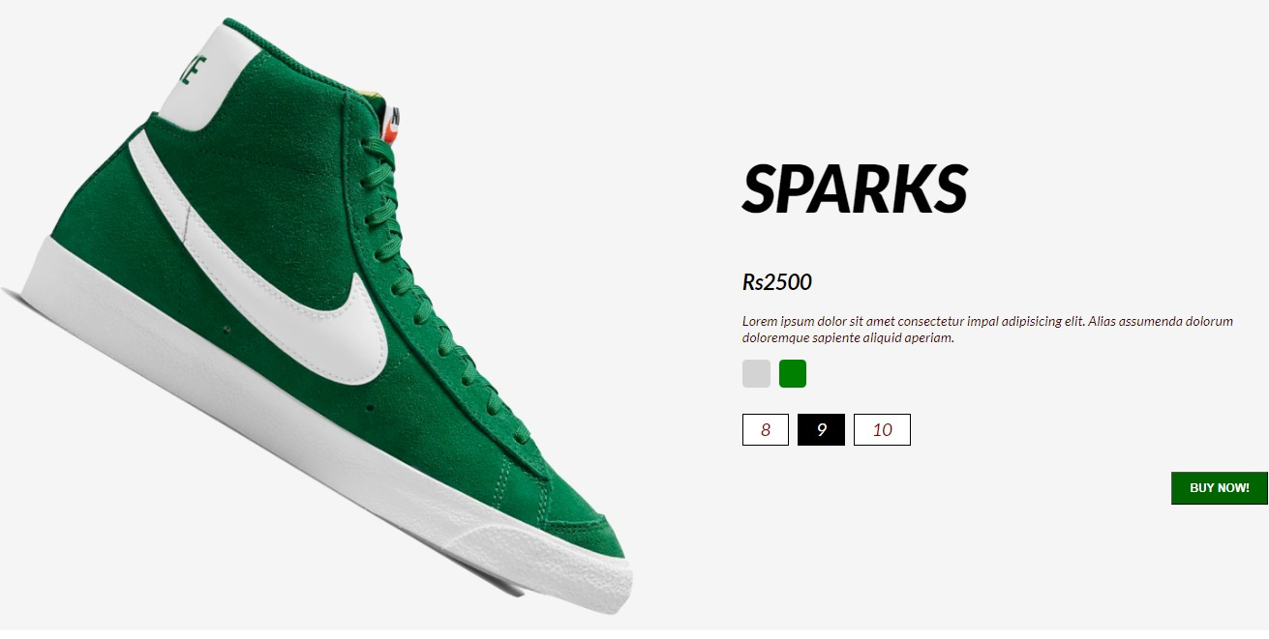
This personalized selection experience not only enhances convenience but also ensures satisfaction, as customers can confidently choose the perfect shoe that aligns with their individual style and preferences. Through this interactive and user-centric approach, we aim to elevate the online shopping journey and exceed customer expectations.
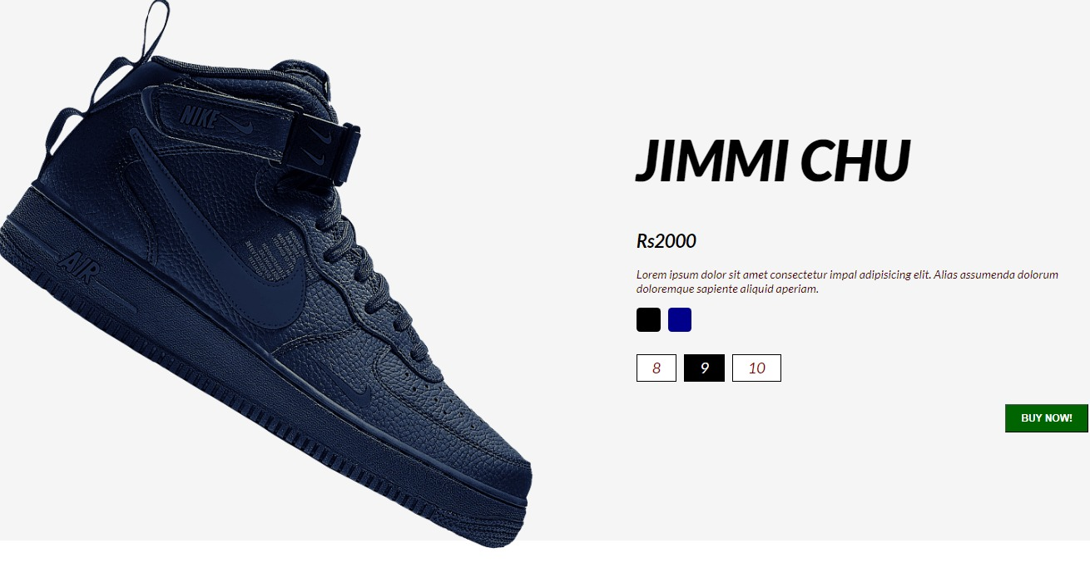

4.4.Secure Payment Method:
Upon selecting their desired shoes, customers are directed to our secure payment gateway, where they can complete their purchase with ease. Our payment process prioritizes both security and convenience, ensuring a seamless transaction experience for every customer.
Customers are prompted to enter their personal details, including billing and shipping information, in a user-friendly form. We employ industry-standard encryption and security measures to safeguard sensitive information, providing customers with peace of mind throughout the payment process.
Our platform supports a variety of payment methods, including credit/debit cards, digital wallets, and other secure online payment options, catering to diverse customer preferences. With flexible payment solutions, we empower customers to complete their transactions using their preferred method, enhancing convenience and accessibility.
By prioritizing security, simplicity, and flexibility in our payment process, we aim to provide a seamless and stress-free shopping experience, ensuring customer satisfaction at every step of their journey.
Top of Form

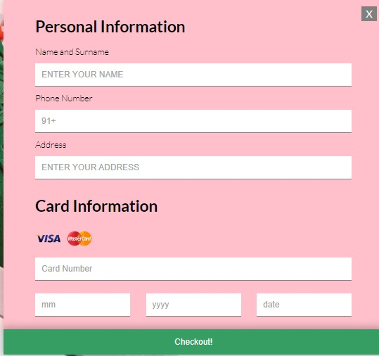

4.6 Visual Inspiration: Explore Our Shoe Gallery
Step into the style with our captivating shoe gallery, where we showcase our collection through stunning imagery that brings each design to life. Immerse yourself in a visual feast of fashion-forward looks, curated to inspire and delight shoe enthusiasts of all tastes.

From elegant heels to sporty sneakers, our gallery offers a diverse array of styles, ensuring something for every occasion and preference. Each photo captures the essence of our shoes, allowing customers to envision themselves wearing their favorite pair with confidence and flair.

Whether you're seeking inspiration for a special event or simply browsing for your next statement piece, our gallery provides a window into the world of fashion possibilities. Explore, dream, and discover your perfect pair as you navigate through our visually captivating shoe collection.
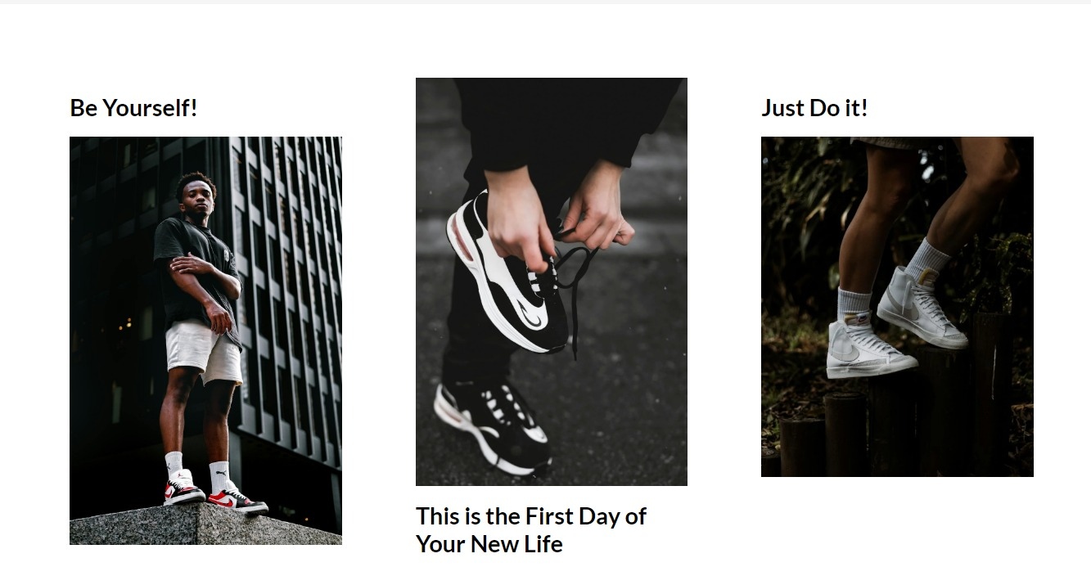

4.7 Discover the Latest Trends: New Arrival Showcase

Be the first to step into style with our exclusive New Arrival showcase, where we unveil the latest additions to our coveted shoe collection. Immerse yourself in a world of fresh designs, curated to keep you on the forefront of fashion trends and elevate your footwear game.

From cutting-edge designs to timeless classics with a modern twist, our New Arrival section features shoes that embody the essence of style and innovation. Whether you're a trendsetter or a fashion aficionado, there's something to captivate every taste and preference.
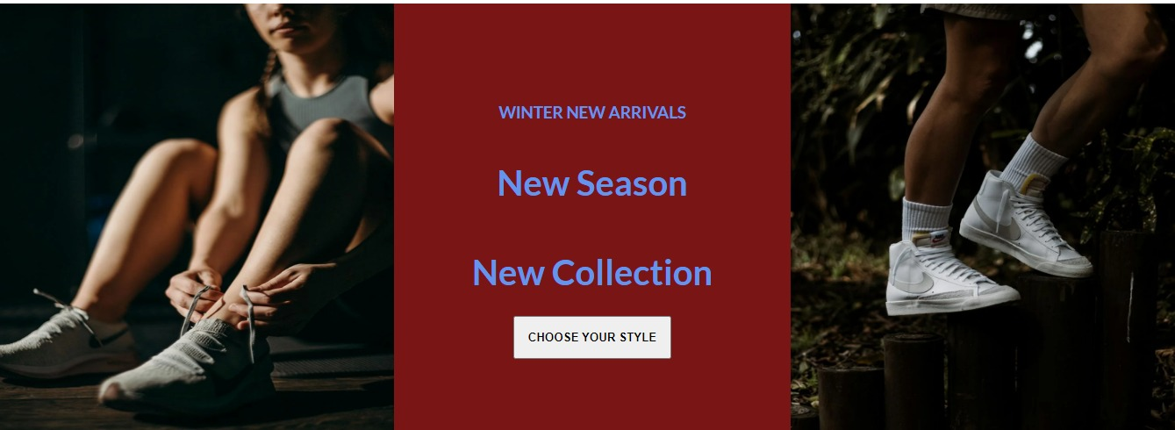

4.8. Connect with Us
In our footer section, we invite you to delve deeper into our brand with the "About Us" feature, where you can learn more about our story, values, and commitment to exceptional footwear. Discover the passion and dedication behind our brand as we share our journey with you.
Stay updated and connected by following us on social media platforms. With just a click, you can access our social media buttons and join our community for the latest news, updates, and sneak peeks of our newest arrivals. Engage with us, share your experiences, and be part of our ever-growing shoe-loving community.
Our footer section serves as a gateway to deeper engagement, offering insights into our brand identity and providing avenues for ongoing connection through social media. Explore, connect, and become part of our journey as we continue to strive for excellence in the world of footwear fashion.



- ADDITIONAL CONSIDERATIONS

  - Accessibility Features:
We are committed to inclusivity, with accessibility features integrated into our website to accommodate diverse needs and provide a user-friendly experience for all.

5.2. Customer Support:
Our dedicated customer support team is readily available to assist you with any inquiries, concerns, or assistance you may require throughout your shopping journey. We prioritize prompt and personalized service to ensure your satisfaction.

.

6. CONCLUSION

I am immensely grateful for the invaluable experience of delving into the realm of front-end web development while tackling real-world challenges head-on. This journey has not only honed my technical skills but has also instilled in me a profound sense of accomplishment and growth. I extend my heartfelt gratitude to Mr. Akhil Sohal Sir for his unwavering support and guidance throughout this endeavor. His mentorship has been instrumental in shaping my understanding and proficiency in web development. As I reflect on this transformative experience, I am inspired to continue exploring and pushing the boundaries of my capabilities in the dynamic world of technology.

